**Useful classroom phrases puzzle**

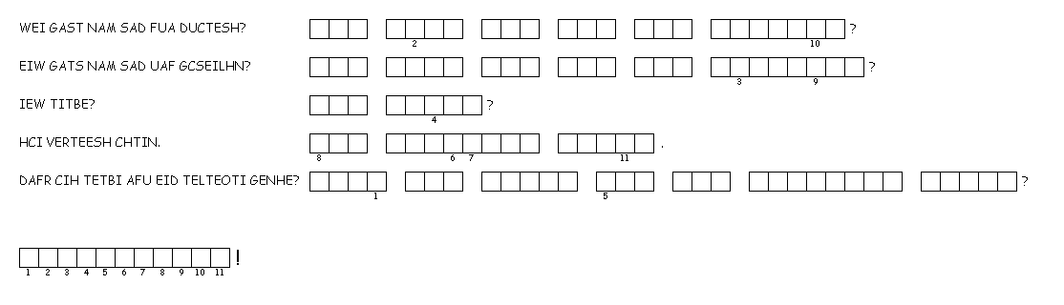

Unscramble each of the clue words. Then copy the letters in the numbered cells to the cells with the same number below them to discover the missing word.